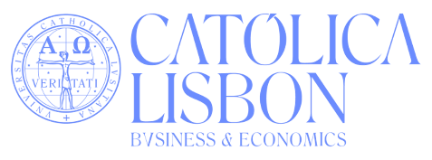
Introduction: In your Personal Statement, please tell us more about yourself, beyond your hobbies or current curriculum. It should have a minimum of 350 and a maximum of 500 words (one Word sheet).
To help you in writing your Personal Statement, consider the following:
- Why did you choose CATÓLICA-LISBON and why do you want to apply to the International Undergraduate Programs?
- What would you like to tell us about yourself that could be relevant in order to motivate your application?
- Describe your most valuable personal experience that made you grow as an individual.
- Tell us about your international background.

Make sure your Curriculum Vitae is updated and reflects all mentioned experiences in your statement.
Signed by,
[Name]
[Date]

